Christmas in Lisbon: An Unexpected Gem for Festive Travellers
From dazzling light displays to bustling markets and river cruises, discover Lisbon at Christmas

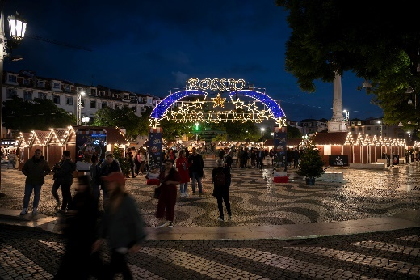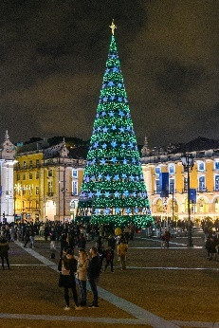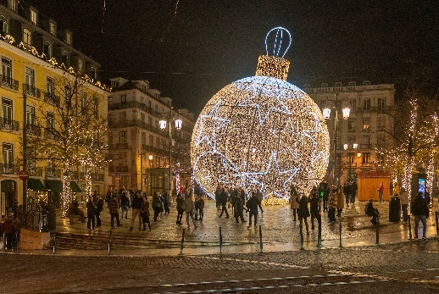

From l to r: Rossio Square, Christmas Tree at Praça do Comércio and street decorations
Download high-res images here.

18 October 2024: Lisbon may not be the first city that comes to mind as a Christmas destination, but through December it offers a mild climate, historic charm and a festive spirit that blends Portuguese traditions with modern attractions. From dazzling light displays to bustling markets and river cruises, the team at Visit Lisboa (visitlisboa.com/en) has picked out the city’s top Christmas attractions that make it an unexpected gem during the festive season.

Wonderland Lisboa
Wonderland Lisboa is one of Lisboa’s largest Christmas markets, transforming Eduardo VII Park into a winter wonderland filled with festive delights. The market’s wooden chalets offer everything from traditional Portuguese Christmas snacks to handcrafted gifts, while an ice rink and Ferris wheel provide fun for all ages. Open from late November until Christmas, visitors can stroll beneath twinkling lights while enjoying sky-high views of the city from the Ferris wheel.

Giant Christmas Tree at Praça do Comércio
Lisbon’s grand plaza, Praça do Comércio, is home to a giant Christmas tree which, at around 30 metres tall, is one of the biggest festive trees in Europe. Decorated with thousands of lights, the tree becomes the centrepiece of the square, creating a festive atmosphere along the banks of the Tagus River. At night, its glow reflects on the river, enhancing the city’s already magical scenery. Another feature of the square over Christmas is a temporary ice-skating rink that is a holiday favourite with locals who are unused to frosty fun.

Christmas Lights in Baixa and Avenida da Liberdade
Lisbon’s streets sparkle with spectacular Christmas light displays, with illuminations bathing the city in a festive glow. Every year, new designs are added to bring a fresh touch and timeless charm to evening adventures through fascinating neighbourhoods that include the historic Baixa district and Avenida da Liberdade, home of Lisbon’s most luxurious shops.

Nativity Scenes at Estrela Basilica
Each year, the Baroque Estrela Basilica showcases one of Lisbon’s most revered nativity scenes, or "Presépios." Crafted with intricate detail, these nativity displays bring to life the story of the birth of Jesus with elaborate figurines and often surprising creative elements. Some of the scenes are set in traditional Portuguese settings, giving visitors a unique twist on the biblical tale.

Christmas Markets
Rossio Square, in the heart of Lisbon, hosts a small and charming Christmas market with traditional stalls offering gift ideas and seasonal foods. For families, the highlight is the Christmas train which takes passengers on a fun ride around the local streets. Another option is Lisbon’s former bull ring, Campo Pequeno, which is transformed into a bustling Christmas Village for two short periods each December. Visitors enjoy a variety of stalls offering everything from handmade crafts to seasonal delicacies, and the market buzzes with festive energy, live music, street performers and a variety of traditional food options.

The winding streets of Alfama and the riverside district of Belém host Christmas markets that bring a touch of old-world charm to the festive season. Smaller than some of the city centre alternatives, visitors can browse stalls selling everything from intricate jewellery to artisanal soaps, with the smell of roasted chestnuts and mulled wine filling the air. These markets are perfect for those looking to escape the hustle and bustle while soaking up the local holiday atmosphere.

Fado Christmas Concerts
The soulful melodies of Fado, Lisbon's traditional music, take on a seasonal flavour over Christmas, with special concerts held in churches, theatres and Fado houses, adding a layer of festivity to the hauntingly beautiful tunes. Performers sing about the nostalgia and warmth of the season, blending their songs with traditional Christmas themes.

Convent Sweets and Festive Pastries
Lisbon has a rich tradition of convent sweets and pastries that is continued into Christmas. Seasonal delights such as Bolo Rei, a Portuguese take on the king cake, and Rabanadas, a cinnamon-dusted bread similar to French toast, fill bakery windows during the period. Many of these pastries originated in the convents where nuns perfected the recipes over centuries.

Christmas Cruises on the Tagus River
The city’s festive lights can be enjoyed from a different perspective with a Christmas cruise on the Tagus River. These evening cruises take passengers along the scenic riverbanks for spectacular views of the illuminated Praça do Comércio, the famous Belém Tower, and other iconic landmarks. With Christmas music playing softly in the background and mulled wine served onboard, the cruises provide a peaceful and magical way to take in Lisbon’s holiday spirit.

For more information, ideas, and inspiration on visiting Lisbon, go to www.visitlisboa.com.

-Ends-

Notes to editors

About Turismo de Lisboa
Turismo de Lisboa is a non-profit organisation established through an alliance of public and private bodies operating in the tourist sector. It has around 900 associated members. Since its inception in 1998, the main objective of this association is to improve and increase the promotion of Lisboa as a tourist destination and therefore enhance the quality and competitiveness of the city.

For media information and images, please contact Hume Whitehead Ltd:
Richard Hume (richard@humewhitehead.co.uk / 020 3375 4050)
Laura Boo (laura@humewhitehead.co.uk / 020 3375 4056)

