EVA AIR AND AIRBUS ESTABLISH SUSTAINABILITY COOPERATION

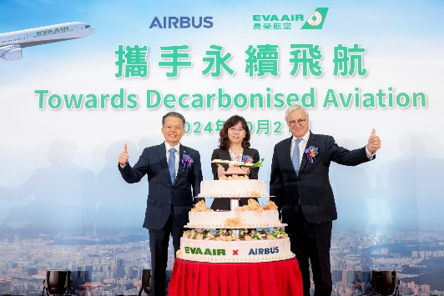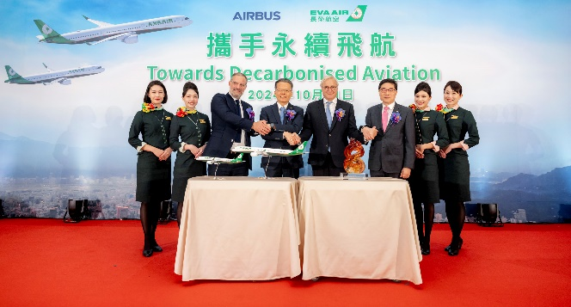
EVA Air, Taiwan’s leading independent airline, and Airbus have embarked on a collaborative effort aimed at increasing SAF development and adoption in the airline’s operations.

The announcement was made during a ceremony in Taipei to celebrate EVA Air’s order of 18 long-range A350-1000 and 15 single-aisle A321neo aircraft, in the presence of EVA Air President Clay Sun, CEO of Airbus Commercial Aircraft Christian Scherer, Taiwan Civil Aviation Administration Director-General Ho Shu-Ping, European trade office representatives, and guests from the Taiwanese travel and cargo industries.

Recognising SAF as a critical pathway to the decarbonisation of the aviation industry, and a key contributor to reaching the Net Zero 2050 target, the joint agreement lays the foundation for the two companies to explore over the next 24 months avenues for decarbonisation within EVA Air’s operations, prepare the ecosystem for sustainable aviation fuel adoption and ensure infrastructure readiness.

“Fuel efficiency, carbon reduction and cabin comfort have become major considerations for airline fleet modernisation, and EVA Air’s announcement late last year to introduce the 33 latest-generation Airbus aircraft underlines our plans to meet future demand. Both companies are working closely in a strategic partnership to promote the use of sustainable aviation fuel and explore more innovative technologies and operational optimisation solutions. These efforts will ensure that we can steadily move towards a Net Zero future,” said Clay Sun, President, EVA Air.

“The aircraft orders we celebrate today elevate the partnership we have with EVA Air to a whole new level. The A350-1000 is the undisputed choice in the large capacity intercontinental segment, with unmatched passenger comfort and an environmental signature superior to any aircraft in its class, present or planned. This allows EVA Air to set new standards for its long-haul operations. In alignment with Airbus' ambition to decarbonise aviation, we are also deepening our collaboration to explore ways for EVA Air to reduce carbon emissions across its operations and prepare for the future adoption of SAF,” said Christian Scherer, CEO, Airbus Commercial Aircraft.

Working closely with EVA Air, Airbus will analyse potential contributions of various measures based on current and future routes, as well as operational practices. The two parties will also study the required measures to prepare for the uptake of SAF on commercial flights, establish procurement processes, manage SAF certification, as well as promote awareness on regular SAF usage.

EVA Air has joined other Asian carriers in committing to the Net Zero 2050 target. This regional commitment aligns with global efforts to reduce aviation’s environmental impact. Taiwan’s aviation industry has also been working to reduce its carbon footprint, with initiatives such as the use of SAF and the adoption of new aircraft technologies.

EVA Air’s recent investment in the latest generation of Airbus aircraft as part of its fleet modernisation programme illustrates its commitment to operating the most efficient aircraft and offering the best passenger comfort. The new fleet will enable an immediate reduction in fuel burn and CO2 emissions of up to 25% as compared to previous generation aircraft.

EVA Air has already demonstrated its leadership with SAF adoption in August 2023 when the carrier performed its first passenger flight from Haneda Airport to Songshan Airport using 40% SAF blend.

The Taiwanese airline has launched several operations improvement programmes, including low-drag approach, continuous descent operations and flexible loading of portable water. The carrier has also implemented near-term initiatives including a carbon offset programme which allows passengers to offer their carbon emissions by contributing to various environmental projects.

As a major lever in the journey towards the decarbonisation of the aerospace industry, SAF brings an average 80% reduction in carbon emissions over the life cycle compared with fossil fuels, from production to end use. All Airbus aircraft are already able to operate with up to 50% SAF. Airbus aims for all its aircraft to be capable of operating with up to 100% SAF by 2030.

To learn more about EVA Air’s travel destinations and award-winning services, and to buy tickets, visit www.evaair.com
Ends

Photo Captions
Caption 1: EVA Air and Airbus celebrated the upcoming introduction of 33 new generation aircraft at today's "Towards Decarbonised Aviation" event. EVA Air President Clay Sun and Airbus CEO Christian Scherer co-hosted the event, and Civil Aeronautics Administration Director General Shu-Ping Ho was also in attendance.

Caption 2: EVA Air President Clay Sun (third from left), Executive Vice President Albert Liao (second from left), Airbus CEO Christian Scherer (third from right), and Airbus Executive Vice President Sales Benoît de Saint-Exupéry (second from right) came together to celebrate the upcoming introduction of 33 new-generation aircraft. This significant investment will not only enhance operational efficiency but also provide passengers with a more comfortable flying experience.

About EVA Air:
A Star Alliance member, EVA Air was established in 1989 as Taiwan’s first privately owned international airline. It is part of the respected Evergreen Group and a sister company to global container-shipping leader Evergreen Line. It flies a fleet of more than 80 Boeing and Airbus aircraft to over 60 international destinations throughout Asia, Oceania, Europe and North America where gateways are Chicago, Houston, Los Angeles, New York, San Francisco, Seattle, Toronto and Vancouver. Travellers can learn more about EVA and schedule, book and buy tickets at www.evaair.com.

Media contacts:
Hume Whitehead – Richard Hume (Richard@humewhitehead.co.uk, +44 (0)203 375 4050)

