Lisbon voted Europe's Best Culinary City Destination

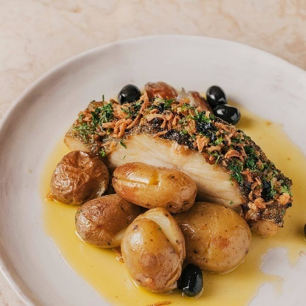
From l to r: Cod dish (Bacalhau_©palaciochiad)
03 October 2024: Lisbon has won, for the first time, the award for Best Culinary City Destination in Europe, at the World Culinary Awards. The honour was received at a ceremony held in Dubai, and among the competing cities were Barcelona, Copenhagen, Florence, London, Paris and Vienna.

Gastronomy is one of the key points when choosing a tourist destination and Lisbon has long been recognised for its diverse and high-quality offer. From typical and local restaurants with traditional food, to signature restaurants and Michelin-starred chefs who reinterpret classic flavours, there is a wide selection that attracts visitors from all corners of the world.

Carlos Moedas, Mayor of Lisbon, said that “it is a source of great pride to see Lisbon's identity and traditions honoured for the first time in this sector and how innovation combines with these gastronomic traditions. It's recognition of the quality of the gastronomy for which Lisbon is so well known and an award that encourages all the professionals who keep it alive. The local economy is increasingly a distinctive factor for the city of Lisbon and gastronomy contributes greatly to the quality of Lisbon's tourism.”

The World Culinary Awards, a “sister” event to the World Travel Awards, are celebrating their fifth edition this year and aim to promote global culinary culture and encourage gastronomic tourism. They highlight the best practices and innovations in the sector and cover various categories, including restaurants, chefs, hotels and other culinary-related establishments. The winners are chosen by public vote.

For more information, ideas, and inspiration on visiting Lisbon, go to www.visitlisboa.com

-Ends-

Notes to editors

About Turismo de Lisboa
Turismo de Lisboa is a non-profit organisation established through an alliance of public and private bodies operating in the tourist sector. It has around 900 associated members. Since its inception in 1998, the main objective of this association is to improve and increase the promotion of Lisboa as a tourist destination and therefore enhance the quality and competitiveness of the city.

For media information and images, please contact Hume Whitehead Ltd:
Laura Boo (laura@humewhitehead.co.uk / 020 3375 4056)
Richard Hume (richard@humewhitehead.co.uk / 020 3375 4050)

