EVA AIR JOINS THE DOW JONES SUSTAINABILITY INDICES (DJSI)
FOR THE FIRST TIME

EVA was recognised as the Top Airline in the 2024 S&P Global Sustainability Assessment

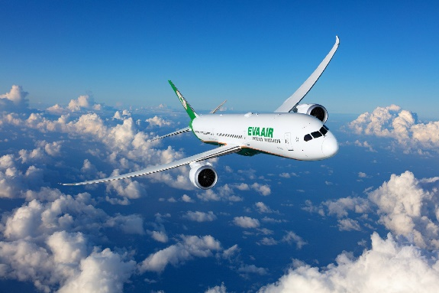

EVA Air, Taiwan’s leading independent airline, has achieved a major milestone in its sustainability journey by debuting on the DJSI Emerging Markets Indices. Due to its leadership and commitment to sustainable practices, the airline secured the highest Environmental, Social, and Governance (ESG) score in the global aviation sector in the 2024 S&P Global Corporate Sustainability Assessment.

The Dow Jones Sustainability Indices are globally recognised benchmarks for responsible investing, assessing companies across environmental, social, and governance dimensions. Over 13,000 companies from 62 industries participated in the evaluation this year. Among the 61 airlines assessed, EVA Air stood out as the top performer, recognised for its comprehensive and well-executed ESG strategies.

“EVA Air was ranked No. 1 in the global airline industry in this year’s S&P Global Corporate Sustainability Assessment and, for the first time, was selected as a constituent of the DJSI Emerging Markets Index,” said President Clay Sun. “This recognition highlights the outstanding performance of our ESG initiatives and the dedicated efforts of all our employees. We remain committed to taking concrete actions to uphold ESG principles, delivering long-term value for both society and our company,” he added.

EVA Air’s inclusion in the DJSI Emerging Markets Indices is a testament to its achievements in corporate sustainability governance. The airline excelled in the environmental and social categories, ranking first in Transparency & Reporting, Risk & Crisis Management, Supply Chain Management, Environmental Policy & Management, Energy, Packaging, Climate Strategy, Transportation Safety, Customer Relations, and Privacy Protection.

As part of its commitment to decarbonisation, EVA Air has been actively integrating Sustainable Aviation Fuel (SAF) into its operations. In August 2023, the airline operated a passenger flight from Tokyo Haneda (HND) to Taipei Songshan (TSA) using SAF with a 40% blend. Most recently, on December 16 2024, SAF with a 30% blend was used on a flight from Incheon (ICN) to Taoyuan International Airport (TPE), reducing approximately 14,000 kilogrammes of carbon dioxide emissions. These initiatives exemplify EVA Air’s dedication to environmental responsibility through concrete action.

EVA Air’s continuous focus on ESG initiatives has earned widespread recognition. In 2024, the airline was honoured at the Taiwan Corporate Sustainability Awards (TCSA) with the Top 10 Sustainability Exemplary Companies Award, the Platinum Award for Transportation Industry - Sustainability Reporting Category, and four individual performance awards. Additionally, EVA Air received a Bronze Class for Sustainability Reporting at the 7th Global Corporate Sustainability Awards (GCSA).

Looking ahead, EVA Air remains committed to advancing sustainability through innovation and collaboration. Through impactful ESG actions, the airline strives to significantly contribute to the sustainable development of the global aviation industry and society.

To learn more about EVA Air’s travel destinations and award-winning services, visit www.evaair.com.

Ends

About EVA Air:
A Star Alliance member, EVA Air was established in 1989 as Taiwan’s first privately owned international airline. It is part of the respected Evergreen Group and a sister company to global container-shipping leader Evergreen Line. It flies a fleet of more than 80 Boeing and Airbus aircraft to around 60 international destinations throughout Asia, Oceania, Europe and North America where gateways are Chicago, Houston, Los Angeles, New York, San Francisco, Seattle, Toronto and Vancouver. Travellers can learn more about EVA and schedule, book and buy tickets at www.evaair.com.

Media contacts:
Hume Whitehead – Richard Hume (Richard@humewhitehead.co.uk, +44 (0)203 375 4050)

